Nama : Asri Nihal Salsabila

NIM : 18090087

Kelas : 5C

1. URL : <http://localhost/web2/index.php/MatakuliahValidation>
2. Source Code

* application 🡪 config 🡪 database.php

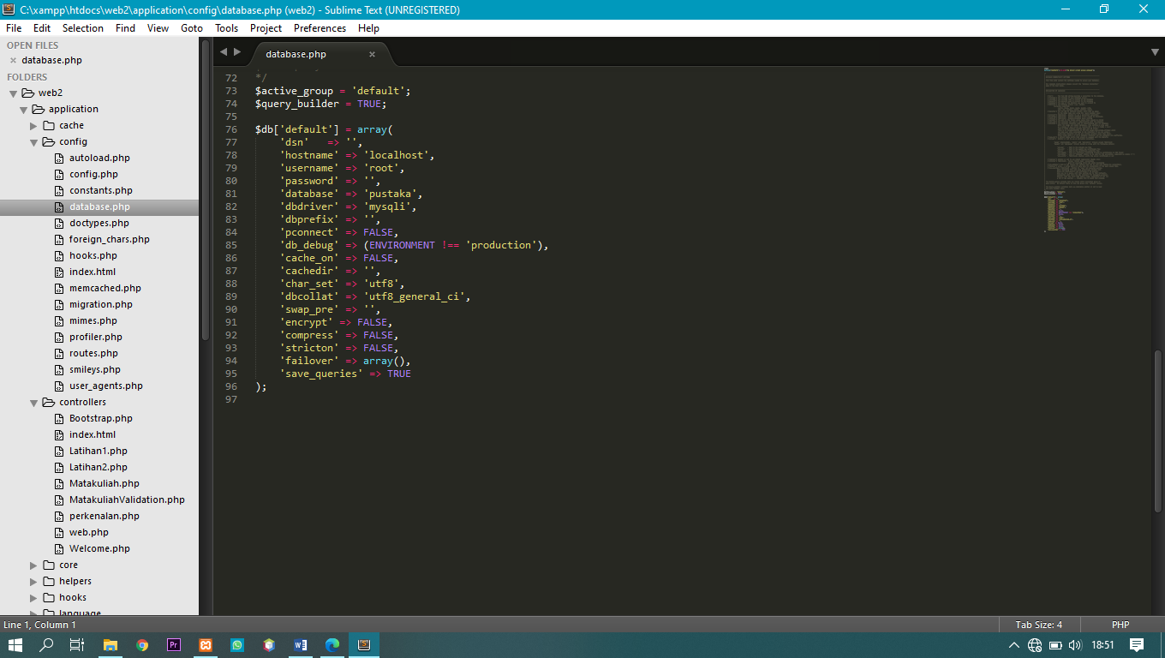

* application 🡪 controller 🡪Bootstrap.php

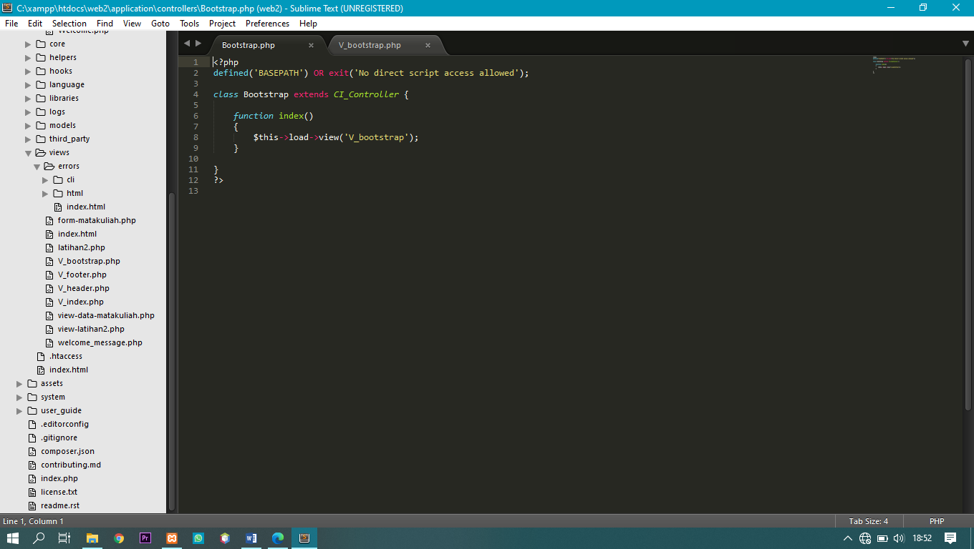

* application 🡪 view 🡪V_bootstrap.php

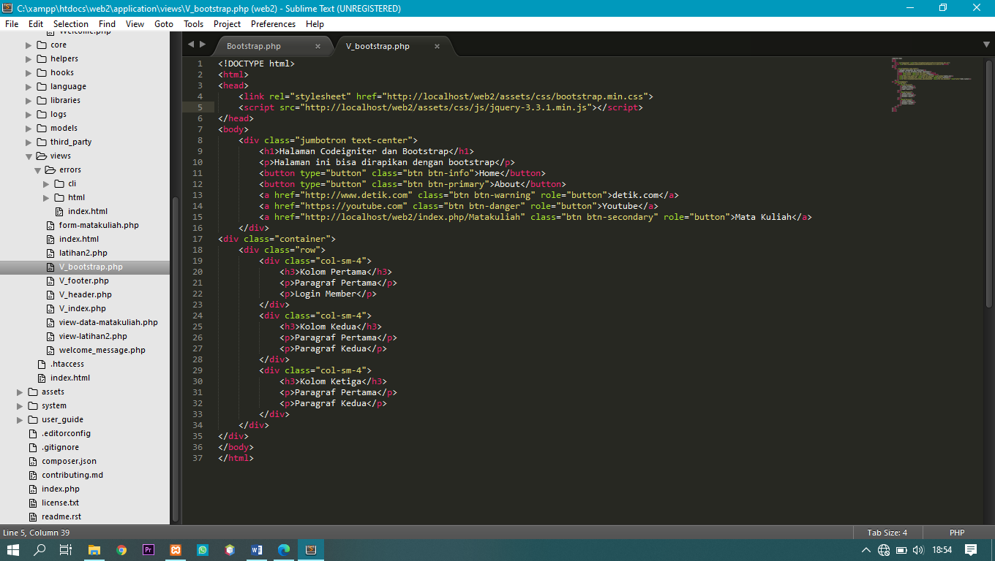

1. Screen Shoot

